Objects and Rules of the

AUSTRALIAN NATIONAL

BUDGERIGAR COUNCIL

INCORPORATED

ARBN 103 608 671

Registered with ASIC as a Company under the Corporations Act - 31st January 2003

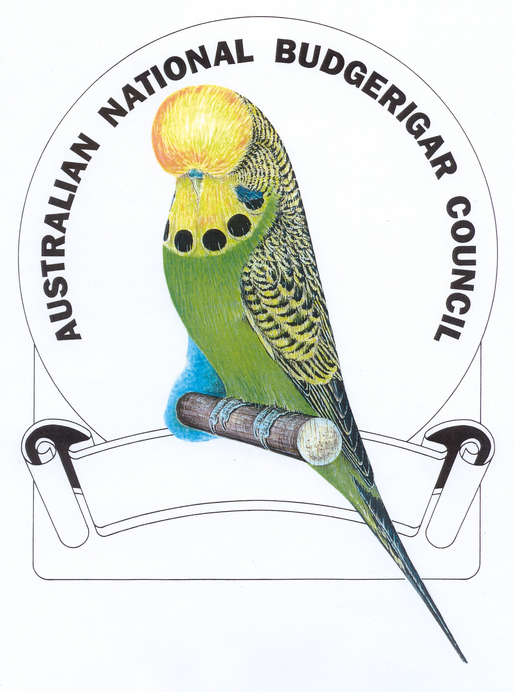
Incorporated in the Australian Capital Territory under the provisions of the Associations Incorporation Act (1991)
AMENDMENT PAGE / HISTORY

DATE | FORUM | DESCRIPTION
31Jan2003 | Form 401B  Number 018579545 | Application for Registration as a Registrable Australian Body (Association)
31Jan2003 | Form 412  Number 019112057 | Certified Copy of Constitution (Registrable Australian Corporation)
4Aug2003 | Form 490A  Number 019438792 | Change to Officeholders of a Registered Body Appoint/cease Directors – Registered Body
May 2004 | Annual General Meeting | Change to Constitution
May 2007 | Annual General Meeting | Change to Constitution
May 2018 | Annual General Meeting | Changes and updates to entire Constitution
Objects and Rules of the

AUSTRALIAN NATIONAL BUDGERIGAR COUNCIL INCORPORATED

CONTENTS
Page
TITLE PAGE

AMENDMENT PAGE 1

PART 1 - PRELIMINARY
1. Name 3
2. Definitions 3
3. Objects 3

PART 2 – MEMBERSHIP
4. ANBC Membership and Policy 4
5. Affiliate Membership 4
6. Resignation / Cessation of membership 5
7. Fees 5
8. Members’ liabilities 5
9. Disciplining of members 5
10. Right of appeal of disciplined member 5

PART 3 – THE COUNCIL
11. Delegates per member body 5
12. The affairs of the Council 6
13. Delegation by Council to sub-Committee s 6

PART 4 – GENERAL MEETINGS OF THE COUNCIL
14. Annual meetings – holding of 6
15. Annual meetings – business at 6
16. Quorum 6
17. Chairing of meetings 6
18. Voting & decisions 7
19. Appointment of proxies 7

PART 5 – THE COMMITTEE
20. Members of the Committee 7
21. The role of the Committee 8
22. Quorum 8
23. Vacancies 8

PART 6 – MISCELLANEOUS
24. Management of funds 8
25. Auditor 9
26. Alteration of objects and rules 9
27. Common seal 9
28 Public Officer 10
29. Custody of books 10
30. Inspection of books 10
31. Dissolution 10

These AMENDED Rules become operative on the 28th May 2018. They are binding on all MEMBER BODIES and AFFILIATED ORGANISATIONS who join the Council.

PART 1 - PRELIMINARY

- NAME

The name of the Incorporated Association is the AUSTRALIAN NATIONAL BUDGERIGAR COUNCIL INCORPORATED hereinafter referred to as “the ANBC”.

- DEFINITIONS

“Financial Year” means April 1st to March 31st each year

“Affiliate bodies” means overseas organisations that represent the interests of breeders of exhibition budgerigars

“Committee” means the President, the Secretary and the Immediate Past President

“The Council” means not more than two delegates per Member Body so appointed

“Delegates” means not more than two representatives of a Member Body who shall be the Council, each delegation of a Member Body shall have one vote only on all matters

“Member Body” means a member organisation of The Council

“Meeting of Council” means a general meeting of Member Bodies of The Council convened in accordance with these Rules

“The Act” means the Associations Incorporation Act 1991 (Australian Capital Territory)

“Secretary” means Secretary / Treasurer

“Special Resolution” means a special resolution defined in the Act

- OBJECTS

The objects of the ANBC shall be :-

- To hold annually, on a rotating basis, where practical, in the State or Territory or, alternatively, a significant region of such a State or Territory of each Member Body (or other location if so agreed), the Australian National Budgerigar Council Championship Show.

- To enable Member Bodies to take cooperative action on matters upon which such bodies agree are of a common interest and are for their mutual benefit in the promotion of exhibition budgerigars.

- To prepare and recommend for adoption by the Member Bodies standard policies for the conducting of budgerigar exhibitions, and any matters incidental to any of the foregoing.

- To prepare and recommend for adoption by the Member Bodies, standard policies for the mutual recognition of judges, exhibitor status, rings, disqualifications, disciplinary matters and matters of a like nature.

- To deal with any matter submitted by Member Bodies in connection with local and overseas Affiliate organisations.

- To compile and maintain The Standard that shall be recognised and adopted by all Member Bodies.

- To form a nationally accredited Judges Panel.

- To meet annually, or at other times as agreed, by electronic or other means, to action on-going business of the ANBC.

PART 2 – MEMBERSHIP

- ANBC MEMBERSHIP AND POLICY

- Member Bodies are eligible for inclusion to the ANBC by a vote of 70% majority of the delegates present but shall be limited to organisations representing the interests of breeders of exhibition budgerigars within a State or Territory of Australia or, alternatively, within a significant region of such a State or Territory. The ANBC shall not accept two organisations purporting to represent the same State, Territory or a region of such a State or Territory.

- Member Bodies are those organisations who the Council admits to membership in accordance with these Rules.

5. AFFILIATE MEMBERSHIP

Applications for Affiliation by overseas organisations that represent the interests of breeders of exhibition budgerigars within an overseas country or within a significant region of that country may be considered by Council.

(a) Such organisations may from time to time be approved for Affiliation by 70% of the Member Body delegates present.

(b) Affiliated organisations and/or their representatives are not eligible for election to Council, the ANBC Committee, or entitled to a vote. They may however, nominate up to two representatives to attend a meeting of the Council as observers only, and shall remain silent unless requested by the Chair to speak.

(c) Affiliate organisations will be granted use of The Standard and access to Judging Accreditation on application following Affiliation in accordance with all ANBC By-Laws and guidelines applicable to full Member Bodies.

- Existing Affiliated organisations are required to re-apply for Affiliation
no later than the 31st March annually. The fee for such Affiliation is to be as determined by the Council at the Annual Meeting.

6. RESIGNATION / CESSATION OF MEMBERSHIP

Any Member Body or Affiliate organisation may at any time by giving notice to the ANBC Secretary in writing, resign its membership, but such resignation shall not free it from liability to pay any contribution which is due and unpaid on the date of resignation.

7. FEES

The ANBC shall be funded in part by equal contributions made annually by the Member Bodies, and any Affiliate organisation fees as determined by the delegates at the Annual General Meeting. This contribution to be a sufficient amount necessary to run the ANBC administration efficiently, to cover the cost of transporting and accommodating the ANBC Secretary in a reasonable manner whilst he/she is attending the Annual General Meeting of the ANBC.

8. MEMBERS’ LIABILITIES

The only liability of each financial Member Body or Affiliate body shall be the total of one membership year’s contribution.

9. DISCIPLINING OF MEMBERS

Any Member Body may at any time be disciplined by the ANBC where a vote of 70% majority by the Member Bodies is obtained at the Annual General Meeting or a Special Meeting so convened.

10. RIGHT OF APPEAL OF DISCIPLINED MEMBER

Where new information regarding any disciplinary action is available this can be presented to the ANBC as an “appeal” and re-voted upon. A vote of 70% majority will be required to overturn any previous decisions on appeal.

PART 3 – THE COUNCIL

11. DELEGATES PER MEMBER BODY

Each of the Member Bodies shall appoint not more than two delegates annually to represent their State or Territory or, alternatively, a significant region of such a State or Territory on the ANBC Executive and where possible they shall be from that Member Body’s governing Committee.

12. THE AFFAIRS OF THE COUNCIL

(a) The ANBC shall manage its own affairs holding meetings at such times and places it deems necessary (plus do all things necessary) for the purpose of carrying out its objects.

(b) Nothing in this Constitution shall affect the right or authority of the Member Bodies to govern affairs in their own State or Territory or, alternatively, a significant region of such a State or Territory.

13. DELEGATION BY COUNCIL TO SUB-COMMITTEES

The ANBC may appoint sub-Committees from time to time as decided by a 70% majority vote of the Member Bodies. These sub-Committees shall report to the ANBC Secretary via electronic medium when required and shall report to the ANBC annually at the Annual General Meeting.

PART 4 – GENERAL MEETINGS OF THE COUNCIL

14. ANNUAL MEETINGS – HOLDING OF

Annual General Meetings of the ANBC will be held on the Monday of the ANBC Championship Show, allowing appropriate time for all matters to be discussed. Voting on important issues, if necessary, shall be held over and decided by postal vote at a later date. These meetings shall be open to observers, who shall remain silent.

15. ANNUAL MEETINGS – BUSINESS AT

Member Bodies may bring any business before the ANBC Annual General Meeting by giving a minimum of three months notice of its intention to the ANBC Secretary but shall strive, prior to the 31st December by electronic medium to action any business as it arrives, to enable considered responses of that business by each Member Body prior to the Annual Meeting – refer clause 3. Objects (j). Such notice shall be supported by full details of the matter to be raised at that meeting. The ANBC Secretary shall communicate the full agenda to the Secretaries of the Member Bodies at least eight weeks prior to the date of the meeting.

16. QUORUM

At any meeting of the ANBC, a quorum shall be delegations from at least half of the financial Member Bodies.

17. CHAIRING OF MEETINGS

The President of The ANBC shall be the Chairperson of all meetings of the ANBC. Should the President not be present within fifteen minutes of the appointed start time of the meeting, those delegates present shall elect a Chairperson from amongst themselves.

18. VOTING & DECISIONS

Every motion submitted to the meeting shall be decided in the first instance by a show of hands, or by poll, if demanded by a majority of Member Bodies present. For constitutional matters, 75% majority is required by those present, for all other matters a simple majority is required unless otherwise stated within these Rules. In the case of a poll by electronic medium, the question shall be put and voted on within a reasonable time limit as set within the motion or by the ANBC Secretary in consultation with the ANBC Committee. Only responses received by that time will be accepted and counted.

19. APPOINTMENT OF PROXIES

If for any reason it is necessary, Member Bodies may appoint substitute delegates or proxies. A list of delegates representing each Member Body is to be tendered to the President or Secretary of the ANBC prior to the start of the Annual General Meeting of the ANBC.

PART 5 – THE COMMITTEE

20. MEMBERS OF THE COMMITTEE

The Committee shall consist of the President, Secretary and Immediate Past President.

(a) The President

(1) Shall be the President or other person so nominated by the following years host Member Body and be sanctioned by the ANBC Executive at the Annual General Meeting and hold office from the 1st of July of that year until the 30th of June the following year.

- May be removed from office prior to his/her completion of term
if so decided by a vote of 70% of the Member Bodies.

(b) The Secretary

- Shall be a delegate or other person so appointed by The
ANBC delegates for a term of one year commencing on the 1st of July of that year until the 30th of June of the following year. Nominations for the position of Secretary shall close with the President of the day just prior to the commencement of the Annual General Meeting.

- May be removed from office prior to his/her completion of term
if decided by a vote of 70% of the Member Bodies.

(3) Shall exercise and perform all the usual secretarial functions, including preparation of agendas, distribution of minutes,
Treasurer’s reports and generally attend to the secretarial work of the ANBC, and compile, coordinate any items or material for information or guidance of the Member Bodies, for discussion and or approval.

(4) Shall provide a fully audited balance sheet to the ANBC’s
Annual General Meeting or whenever one is required.

(c) The Immediate Past President

(1) Shall be the Immediate Past President or other person so nominated and be sanctioned by the ANBC Executive at the Annual General Meeting and hold office from the 1st of July of that year until the 30th of June the following year.

(2) May be removed from office prior to his/her completion of term
if so decided by a vote of 70% of the Member Bodies.

21. THE ROLE OF THE COMMITTEE

(a) The Committee shall have the management of the affairs of the ANBC other than those functions that are required by these Rules.

(b) The Secretary, shall in combination with the President and Immediate Past President, or by majority vote of the Committee, submit any particular matter of urgency to the Member Bodies by electronic medium, and the vote on such matter is to be taken accordingly.

22. QUORUM

A quorum shall be two members of the Executive.

23. VACANCIES

(a) A vacancy for the position of President shall be filled from the following years host member body at the Annual General Meeting.

- A vacancy for the position of Secretary shall be decided by a vote of
the Member Bodies after nominations from the Member Bodies at the Annual General Meeting.

(c) A vacancy for the position of Immediate Past President shall be filled by the previous year’s President or an individual from that member’s body at the Annual General Meeting.

PART 6 – MISCELLANEOUS

24. MANAGEMENT OF FUNDS

- The Secretary shall maintain two bank accounts on behalf of the ANBC.

- Accounts are to have two (2) signatories i.e. the ANBC Secretary and the Secretary or Treasurer of the Member Body of the State or Zone in which The ANBC Secretary resides.

- An ANBC Ring Levy as determined by the Committee will apply to all rings purchased from the appointed ring supplier and these rings will all carry the ANBC symbol together with an annual changing code/ symbol given solely to the supplier by the ANBC Secretary

- The assets and income of the ANBC shall be applied solely in furtherance of the above-mentioned objectives and no portion shall be distributed directly or indirectly to individual members of the ANBC except as bona fide compensation for services rendered or expenses incurred on behalf of the ANBC.

(e) The assets and income of the ANBC shall be applied solely in furtherance of the above mentioned objectives and no portion shall be distributed directly or indirectly to individual members of the ANBC except as bona fide compensation for services rendered or expenses incurred on behalf of the ANBC.

25. AUDITOR

(a) At each Annual General Meeting, the Member Bodies present shall
appoint a person who is not a Member or the Public Officer of the ANBC as the Auditor.

- The auditor’s fee shall be paid by the ANBC.

26. ALTERATION OF OBJECTS AND RULES

- Clauses within these Rules shall not be altered, waived or amended except at the Annual General Meeting of the ANBC. A notice of intention to propose a resolution as a special resolution is to be in writing and signed by the Secretary of the Member Body giving a minimum of three months notice of its intention to the ANBC Secretary as per clause 15; and

- It is passed by at least 75% majority of those Member Bodies present entitled to vote in person or by proxy at the meeting.

- COMMON SEAL

  - The Secretary shall be responsible for the safe keeping and use of the
Common Seal of the ANBC.

  - The Common Seal shall not be affixed to any instrument except by the
authority of the Member Bodies and the affixing thereof shall be attested by the signature of two members of the Committee or of one member of the Committee and of the Public Officer of the ANBC or such other person that the Member Bodies may appoint for that purpose, and that attestation is sufficient for all purposes that the seal was affixed by authority of the Member Bodies.

- PUBLIC OFFICER

  - The Public Officer shall be appointed annually at the Annual General
Meeting of the ANBC and must be a resident of the ACT and be at least 18 years of age.

  - If a vacancy occurs as per Section 64 of the Act, the Committee of the
ANBC must appoint a person to fill the vacancy as per 28 (a) of these Rules within 14 days of the vacancy.

  - If the Committee without reasonable cause does not comply with
28(b) of these Rules, each member of the Committee commits an
offence.

29. CUSTODY OF BOOKS

Subject to the Act, the Regulations and these Rules, the Secretary shall keep in his or her custody or under his or her control all records, books and other documents relating to the ANBC.

30. INSPECTION OF BOOKS

Requests for inspection of the ANBC Books of Account and other documents may be made through the Secretary at a convenient time between the hours of 9 a.m. and 5 p.m. Mondays to Fridays.

31. DISSOLUTION

In the event of dissolution of the ANBC, the following shall occur. If there remains, after satisfaction of all its debts and liabilities, any property whatsoever, the same shall not be paid to or distributed among individual members of the ANBC, but shall be given or transferred to some other organisation or organisations having similar objects to that of the ANBC. Such organisation/s is to be determined by the Member Bodies of the ANBC.

10 Pages / 31 Rules

